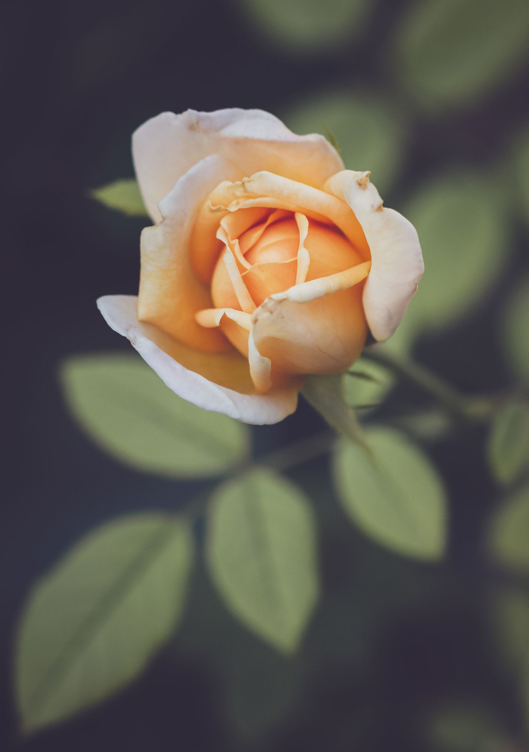

Mom

Dear mom,

thank you for being such an amazing mother through all these years. To properly celebrate you, we will take you to the spa next weekend!

Happy Mother’s Day!

